**Name :SUMAIR IRSHAD**

**Rol_no :GIL-DSAI-266**

**Subject :AI &Data Science**

**Link:** **https://public.tableau.com/app/profile/sumair.irshad/viz/RevenueGenertion/CustmerAnalysis**

**ASSIGNMENT DASHBOARD**

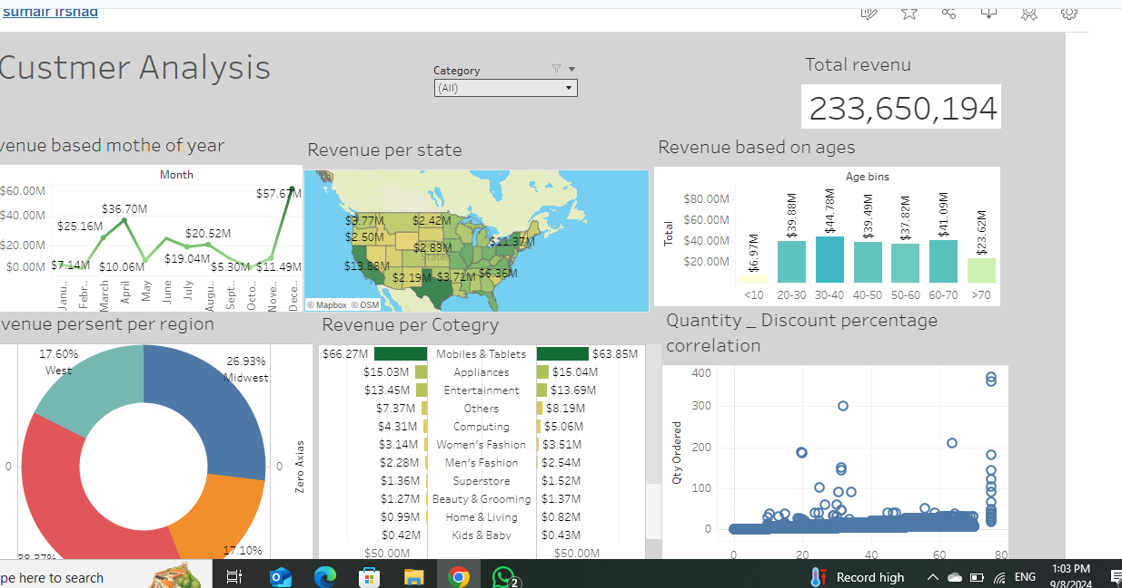

**REPORT DASHBOARD**

This image presents a  **Revenue of USA Dashboard** that provides a comprehensive overview of sales performance through multiple key metrics. Below is a breakdown of the report:

### 1. ****Key Performance Indicators (KIPs)****:

* **Orders**: 28,639,2 orders have been processed.
* **Sales**: Total Revenue amount to $233.65 million
* **Profit**: A total revenue of age bases of $80 million has been generated.
* **Ship Years**: The average shipping time is 1 year

### 2. ****Revenue Analysis****:

* **Revenue generated of super store**
  + Revenue of one year 60 millions
  + Female revenue 66.27 million
  + Male revenue63.85 million
* **Revenue by Region**:
  + West: 17.6%
  + Midwest:26.93 %
  + Northeast: 17.10%
  + South: 38.37%
* **Revenue generated based on age**:
  + <10 years old: 6.97millon
  + 20 to 30 year old: 39.88 million
  + 30 to 40 year old: 44.78 million
  + 40 to 50 year old:39.49million
  + 50 to 60 year old:37.28 million
  + 60 to 70 year old:41.9 million
  + <70 year old:23.62million

### 3. ****Revenue Trends****:

* **Revenue based age**: There is a steady rise in revenue from the beginning of the age greater than10 year old, with a up and the revenue and peak age rise 30 to 40 years .
* **Revenue by moths of year**: The profit curve mirrors the revenue trend, though more fluctuations are observed throughout the year.

### 5. ****Category and Sub-Category Analysis****:

* **revenue by Category**:
  + Appliances: $30.07million
  + computing: $9.37 million
  + Home &Living: $ 1.27million
* **Sales by Sub-Category**:
  + superstore: $3.1 million
  + soghaat: $0.27 million
  + phone & tablets: $130.12 million

### 6. ****Geographical Insights****:

* The map in the top-right section shows **Revenue by State**, indicating sales distribution across North America, with key locations highlighted.

### Summary:

This dashboard provides a detailed visualization of the “revenue” performance across different categories, regions, Ages, and time periods. It shows that the **South region** has the highest revenue genertion, **Mobiles &Tablets** gentered higest revenue of total revenue of year .